Claim Registration screens documentation

1) Accident screen

2) Claims Screen – when OD Selected

3) OD PD BI Screen – When PD / BI Selected

4) Service provider screen – when insurer selected

1) Accident Screen
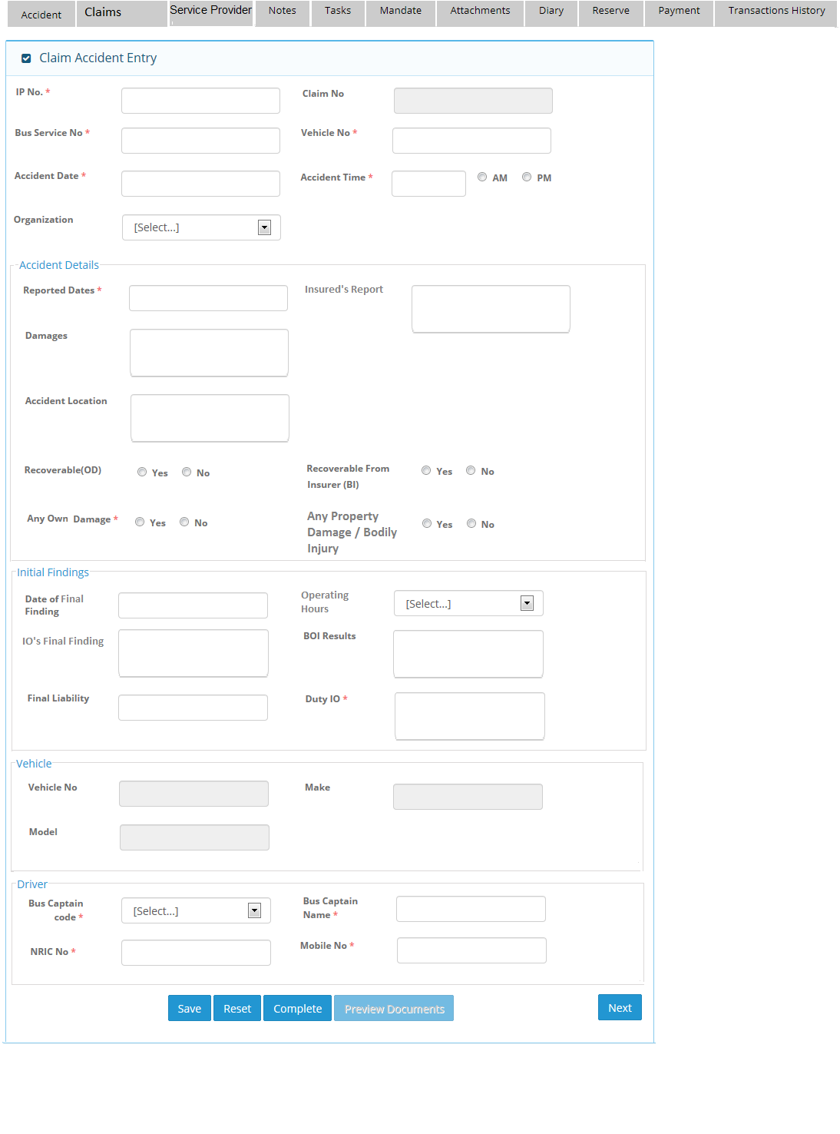

2) Claims Screen when Own Damage selected

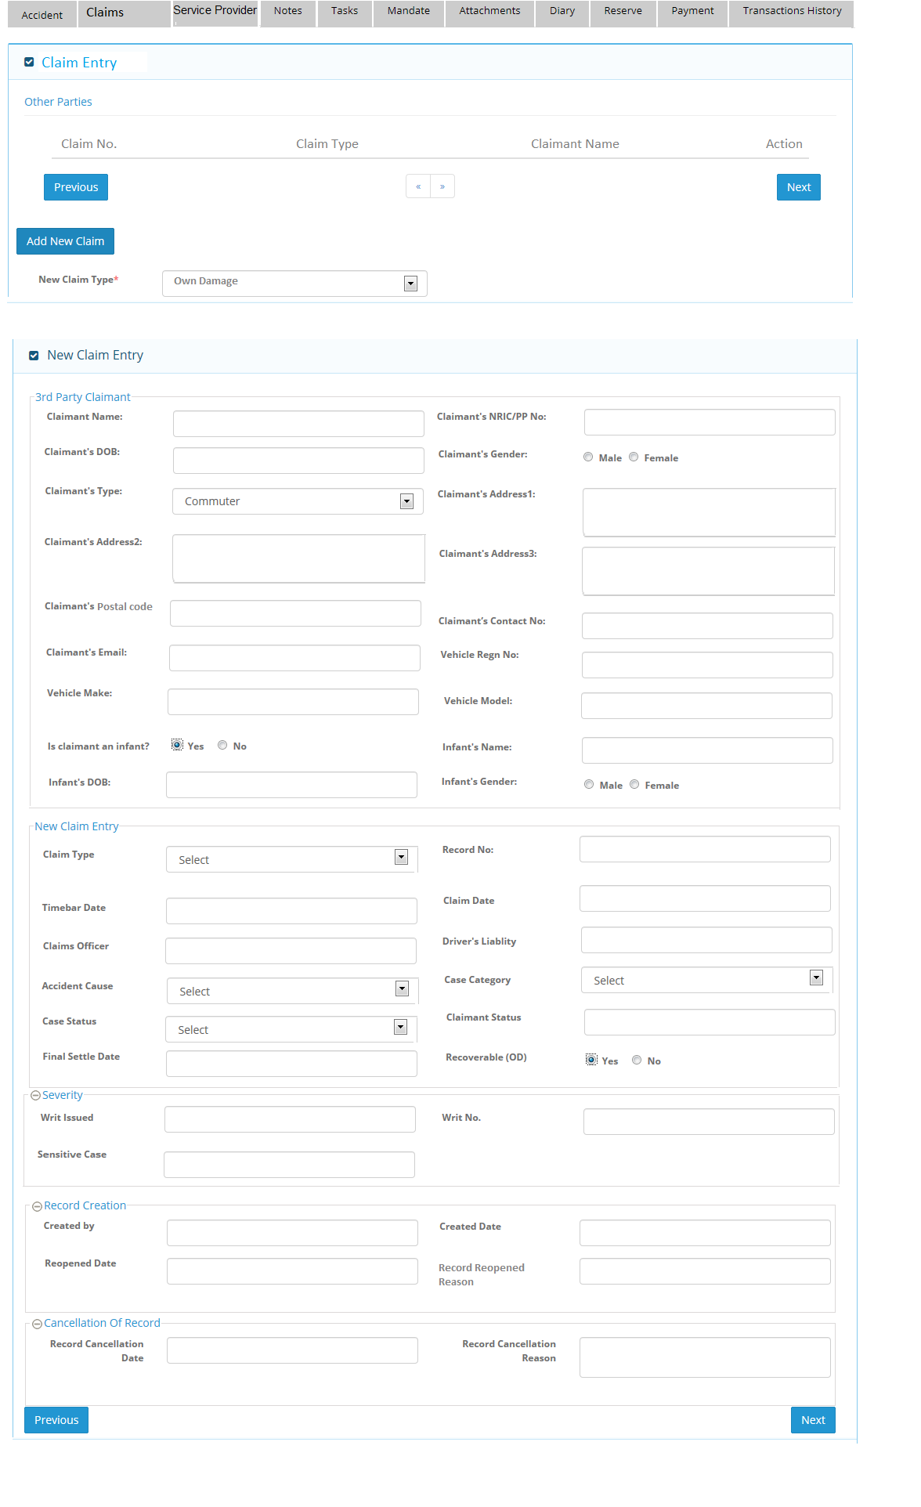

3) Claims Screen when Property Damage selected

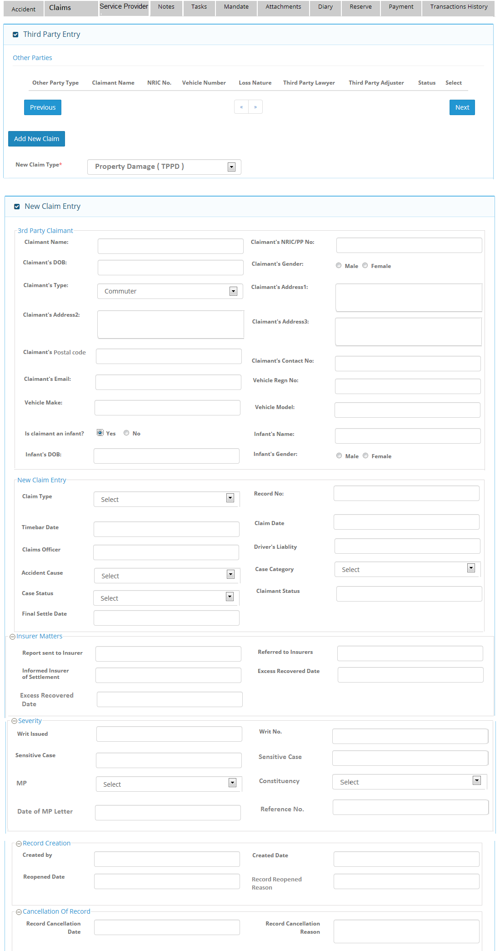
Note: For Bodily injury, user will choose new claim type as “ Bodily injury” and same screen will come for this option.

4) Service provider screen – when insurer selected
